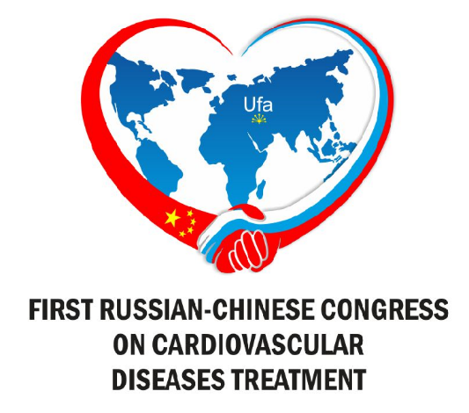 Informational letter

First Russian-Chinese Congress on cardiovascular diseases treatment (hereinafter Congress) is going to be held on 14-15th June 2018 in Ufa.
The Congress organizers are:
- Government of Bashkortostan Republic;
- Ministry of Healthcare of Bashkortostan Republic;
- Bashkir State Medical University;
- Cardiology Republic center.

Participants of the Congress:
- Harbin state Medical University;
- Sechenov First Moscow State Medical University of the Ministry of Health of the Russian Federation;
- Russian-Chinese Association of Medical Universities;
- “Volga-Yangzi” University Association;
Main sections of scientific program:
- Basic research in cardiology;
- Strategies for cardiovascular risk reduction: how save patients’ lives;
- Heart failure: new strategies of diagnostics and treatment;
- Combinational therapy of arterial hypertension;
- Acute coronary syndrome;
- Interventional cardiology 2018;
- Arythmology – invasive and noninvasive treatment;
- Сurrent trends of cardiosurgery;
- Actual problems of heart transplantation;
- Cardioreabilitation: improvement of quality of life and life expectance.
In the framework of scientific program following events are going to be held:
- Plenary sessions;
- Sections sessions;
- Workshops;
- Young cardiologists-investigators section;
- Educational seminars.
All the Congress events are going to contribute to closer Russian-Chinese cooperation in matters of cardiology, exchange of experience in formation and promotion of healthy lifestyle priorities, active longevity. Also these events are going to promote further development and quality improvement of specialized, including high-tech, medical care for population as well as advanced training of cardiologists, cardiovascular surgeons, doctors of interventional radiology, physicians of functional diagnostics, general practitioners, doctors of other related specialties.
More than 2000 participants from Russian Federation, People’s Republic of China, SIC countries and far abroad are expected to attend the Congress, including leading specialists of federal centers, chief stand-in specialists of federal districts and regions of Russia.
In the framework of the Congress there will be exhibition of Russian and foreign medical industry advances conducted.
Abstract digest based on the Congress materials will be published.
We invite all the interested participants to take part in the Congress: cardiologists, general practions, intensive care specialists, scientists, young investigators, cardiointenventionists, cardiosurgeons, scientists.
Abstracts: abstracts are accepted until April 1, 2018.
The abstracts are accepted only in electronic form (version Word 97 and higher). The number of abstracts from one author is unlimited.
The volume of abstracts: abstracts are accepted up to 3 pages of text (a line spacing 1.5, Times New Roman font, size 14) including the title of the abstract, surnames and initials of authors, names of organizations completely, city, addresses of organizations, contact phone number and e-mail of the responsible author, text of theses.
The content of abstracts should reflect: aim, methods of research, results, and conclusions.
Attention! Abstracts will not be subject to editorial revision.
Publication of abstracts is free of charge.
Abstracts should be sent by e-mail: http://cardio.bashgmu.ru with a mandatory attached Word document with a note "I Russian-Chinese Congress on the treatment of cardiovascular diseases".
Young scientists Competition:
Young scientists aged up to 35 years are allowed to participate in the competition. The author (without co-authors) submits only one work for the competition.
To participate in the contest it is necessary to send the following package of documents (young.rus-chi@yandex.ru) with a note "To the competition":
1. Abstracts of the oral report (are made in accordance with the requirements for abstracts);
2. The completed registration card on the site: cardio.rus-chi@yandex.ru;
3. A copy of the passport page with the date of birth.
The documents for participation in the competition are accepted until April 1, 2018. After receiving the application, the organizing committee will send you a confirmation to the email address indicated on the registration card.
Works are accepted both in Russian and English (preferably).
The Program Committee will review the application and send you a notification on the inclusion in the program of an oral report (required only in English!) until June 01, 2018.
Attention! Documents received after 01.04.2018 will not be considered.

Oral report:
The duration of the oral presentation is 10 minutes + 5 minutes for the discussion. Applications for oral presentations are accepted together with abstracts until April 1, 2018.
The Program Committee of the Congress will consider the application and will send you a notification on inclusion of the report in the program until June 01, 2018.

Poster report:
Applications for poster presentations are accepted together with the abstracts until April 1, 2018. The Program Committee of the Congress will review the application and will send you a notification on the inclusion of the poster report in the program until June 01, 2018.
The organizing committee will send you the requirements for submitting the poster report with the notification.
Сompetition for the best poster presentation will be held among the poster presentations.
Listener:
To participate in the Сongress in the status of the listener, you must pass the mandatory registration on the website: http://cardio.bashgmu.ru.
Check in:
In order to become a registered participant of the congress, it is necessary to register on the website: http://cardio.bashgmu.ru.
Registered participants are those who passed preliminary registration before June 10 and received confirmation from the organizing committee.
Preliminary registration of participants until June 10, 2018.
The official day of registration of participants on the spot is June 14, 2018.
Contact information of Organizing Committee:
еmail: omorkd@mail.ru
Venera R. Kamalova: +7 (347) 255-61-12
Elina M. Husainova: +7 (347) 255-64-35

